**Project Title: Breast Cancer Detection**

**Authors: John Clements, Rong Huang, Shantel Ward**

**Team Number: Group 9**

**Introduction**

Breast cancer is a type of cancer that starts in the breast. Breast cancer cells usually form a tumor that can often be seen on an x-ray or felt as a lump [1]. Breast tumors are either benign (non-cancerous) or malignant (cancerous). Since cancer is life threatening, it is crucial to predict if a breast tumor is benign or malignant with the highest possible accuracy levels.

***Purpose***

The purpose of this statistical analysis is to examine the ways in which malignant and benign tumors differ in their characteristics. The secondary purpose is to determine if an informative lower dimensional structure of the variables exists, and use that structure to train classification models to predict whether a mass is benign or malignant. Our goal is to select the classification model that yields the highest accuracy, but also to discuss the relative costs of False Positives versus False Negatives.

***Scientific Questions***

1. Are there statistically significant differences between mean vectors for benign tumors and malignant tumors?
2. Can we use Principal Components Analysis (PCA) to reduce the dimensionality of the data and to identify/summarize crucial variables?
3. Which classification model yields the highest accuracy for predicting if a tumor is benign or malignant?

***Data Description***

The data was collected from 699 patients of Dr. William H. Wolberg at the University of Wisconsin between January 1989 and November 1991. Samples arrived periodically as Dr. Wolberg reported his clinical cases. Measurements were derived from fine needle aspirations of human breast masses and analyses were performed on the masses. Each observation is described by the following nine features: Clump Thickness, Cell Size Uniformity, Cell Shape Uniformity, Marginal Adhesion, Single Epithelial Cell Size, Bare Nuclei, Bland Chromatin, Normal Nucleoli, and Mitosis.

The fine needle aspirates for these nine features were graded 1 to 10 at the time of sample collection, with 1 being the closest to benign and 10 the closest to malignant [2]. Each observation has one of two possible classes: benign or malignant. In the dataset, the benign class is labeled as 2 and the malignant class is labeled as 4. 458 (65.5%) of the observations were classified as benign and 241 (34.5%) of the observations were classified as malignant. The dataset used for this analysis is the Breast Cancer Wisconsin (Original) data set sourced from UCI’s Machine Learning Repository [3].

***Overview***

There are significant differences in mean vectors between benign and malignant masses. Moreover, the mean values of each variable are larger in the malignant masses than in the benign masses, which is shown using Bonferroni intervals for the differences of each variable. The statistically significant differences in mean vectors are sufficiently summarized in a lower dimensional space. The two dimensional subspace parameterized by the first two principal components explains almost 74% of the variance in the training data set. Classification algorithms trained on this subspace achieved accuracies in excess of 95% on withheld testing data compared to a no information rate of about 69%.

In the remainder of this paper we will discuss the steps taken for handling missing data and data preprocessing. Then we will summarize statistical methods used and the required assumptions for the Hotelling’s $T^{2}$ Two Sample test, Principal Component Analysis, and the Classification models. The results section follows and provides interpretations for the key findings. The R code to generate the analyses can be found in the appendix section and all references used can be found in the references section.

**Methods: Data Analysis**

The data preprocessing and statistical analysis was performed using R version 4.0.2.

***Missing Data***

Upon review of the dataset, missing values were identified in the Bare Nuclei feature for 16 observations. The missing values are denoted as “?” in the dataset. The missing Bare Nuclei values were imputed with the median of the non-missing Bare Nuclei values from the corresponding class (benign or malignant). For example, if the missing Bare Nuclei was of the benign class, then that missing value was imputed with the median of the Bare Nuclei values that were in the benign class. A new column, Bare Nuclei Revised, was added to the data set and this new column includes the imputed values.

***Summary Statistics: Mean***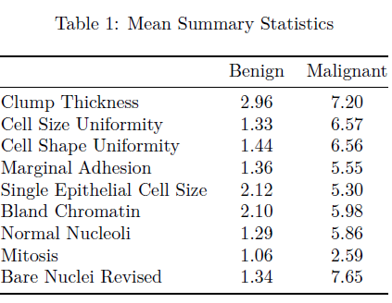

Table 1 shown to the right, shows the mean value for each feature by class (benign or malignant). For the benign class, each of the means fall between 1 and 3. For the malignant class, each of the means fall between 5 and 8 with the exception of Mitosis. The Mitosis mean for the malignant class is 2.59 which is far below the means for the other features in the malignant class.

***Summary Statistics: Standard Deviation***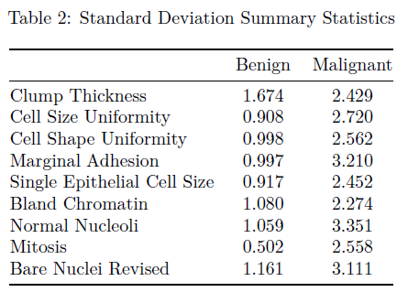

Table 2 shown to the right, shows the standard deviation value for each feature by class (benign or malignant). For the benign class, each of the standard deviations fall between 0 and 2. For the malignant class, each of the standard deviations fall between 2 and 4. This indicates that there is more variability in the malignant class when compared to the benign class.

***Data Preprocessing***

After imputing the missing Bare Nuclei values, the Bare Nuclei Revised variable was converted to an integer and the Class variable was converted to a factor with levels 2 and 4. Then the observed data was randomly split into a testing and training dataset. 70% (n = 489) of the observations were assigned to the testing dataset and 30% (n = 210) of the observations were assigned to the training dataset. A random seed was set for reproducibility.

**Methods: Statistical Models**

Let us define the $p$ observed features in a data vector, $X$, such that $X = (X_{1}, ...,X_{p}){}^{T}$ where

${X_{1 }=Clump Thickness in \left\{1,2,3,4,5,6,7,8,9,10\right\} }_{}$

${X_{2 }=Cell Size Uniformity in \left\{1,2,3,4,5,6,7,8,9,10\right\} }_{}$

${X_{3 }=Cell Shape Uniformity in \left\{1,2,3,4,5,6,7,8,9,10\right\} }_{}$

${X_{4 }=Marginal Adhesion in \left\{1,2,3,4,5,6,7,8,9,10\right\} }_{}$

${X_{5 }=Single Epithelial Cell Size in \left\{1,2,3,4,5,6,7,8,9,10\right\} }_{}$

${X_{6 }=Bland Chromatin in \left\{1,2,3,4,5,6,7,8,9,10\right\} }_{}$

${X_{7 }=Normal Nucleoli in \left\{1,2,3,4,5,6,7,8,9,10\right\} }_{}$

${X_{8 }=Mitosis in \left\{1,2,3,4,5,6,7,8,9,10\right\} }_{}$

${X_{9 }=Bare Nuclei Revised in \left\{1,2,3,4,5,6,7,8,9,10\right\} }_{}$

***Hotelling’s $T^{2}$ Two Sample Test***

Multiple variables were collected to characterize benign and malignant tumors, and one of our interests is to investigate whether mean values of those variables differ between the two classes. The dataset contains measurements of *p* = 9 characteristic vairables of $m=$ 458 benign tumors and $n=$ 241 malignant tumors:

$X_{i }={(X_{1i }, X_{2i },...{, X}_{pi })}^{T}$ for the $i-th$ subject with benign tumors, ${i = 1, ..., m; }_{ }$ $Y_{j }={(Y_{1j }, Y_{2j },...{, Y}_{pj })}^{T}$ for the $j-th$ subject with malignant tumors, ${j = 1, ..., n. }_{ }$

Benign tumors: $X_{1 }, ... X_{p }$ ~ $N(μ_{1}, Σ_{})$

Malignant tumors： $Y_{1 }, ... Y_{p }$ ~ $N(μ_{2}, Σ_{})$

Two mean vectors are

$μ_{1}=E(X_{i})=({\underline{X}}_{1},{\underline{X}}_{2}, ..., {\underline{X}}_{p})$, $μ_{2}=E(Y_{j})=({\underline{Y}}_{1},{\underline{Y}}_{2}, ..., {\underline{Y}}_{p})$

We want to test $H_{0 }:μ_{1}=μ_{2}$ vs. $H_{a }:μ_{1}≠μ_{2}$. Note Hotelling’s $T^{2}$ Two Sample Test makes the following assumptions [4]:

* Both populations are multivariate normal.
* Both populations have the same variance-covariance matrix $Σ_{}$.
* Both samples are mutually independent.

Given the measurements which rate each feature from 1, least cancerous, to 10, most cancerous, we expect the measurements for benign masses to be skewed right with most measurements being close to 1. This is confirmed by histograms of these variables shown in the appendix as Figure 7. Given our sample sizes for each class, Hotelling's $T^{2}$ Two Sample Tests are robust to the violations of assumptions 1 and 2.

The difference $μ_{1}-μ_{2}$ can be estimated by $\underline{X}-\underline{Y}$ as shown below:

$\underline{X}-\underline{Y}$ ~ $N[μ_{1}-μ_{2}, Σ_{}(\frac{1}{m}+\frac{1}{n})]$

To test the hypothesis, we used a two-sample Hotelling’s test. The test statistic is

$T^{2}=\frac{m+n-p-1}{(m+n-2)p}{(\underline{X}-\underline{Y})}^{T}{\{S_{pool}(\frac{1}{m}+\frac{1}{n})\}}^{-1}(\underline{X}-\underline{Y})$

where $S_{pool}$ = $\frac{(m-1)S_{1}+(n-1)S_{2}}{m+n-2}$ is called the pooled covariance matrix, and it is an estimator of $Σ_{}$. $S_{1}$ and $S_{2}$ are sample covariance matrices for the X and Y samples, respectively. We reject the $H_{0 }$ if observed value of $T^{2}$ exceeds $F_{p, m+n-p}(α)$ at $α=$ 0.05 significance level.

To quantify the difference between each element of $μ_{1}$ and $μ_{2}$, we constructed simultaneous confidence intervals which are called the Bonferroni intervals as shown below.

For $μ_{1k}-μ_{2k}: ({\underline{x}}_{k}-{\underline{y}}_{k})±t_{m+n-2}(\frac{α}{2p})\sqrt{(\frac{1}{m}+\frac{1}{n})S_{pool, kk}}$

Where $S_{pool, kk}$ is the *k*-th diagonal entry of $S_{pool},$ and $μ_{1k}-μ_{2k}$ is the difference between the k-th variables in the mean vectors $μ_{1} and μ_{2}$. The intervals are constructed at $1-\frac{α}{p}$ confidence level.

***Principal Components Analysis (PCA)***

The main goal of PCA is to identify linear combinations of $X$ of the form $Y_{i}= a_{i}^{T }X, where i = 1,2,...,q,$ that explains most of the variability in $X$. Usually, $q < p.$ $a_{i}^{T }$ is a vector of length $p$ which represents the PC loadings and tells us how the original features are weighted to get the PCs. $Y_{i}$ represents the new variables and are ordered according to their importance. For instance, $Y_{1}$ is designed to capture the most variability in the original features by any linear combination. $Y_{2}$ then captures the most of the remaining variability while being uncorrelated to $Y_{1}$, and so on. We hope that the first few $Y_{i}'s$ capture most of the variability in $X$. If we are able to capture most of the variability in $X$ with a few $Y_{i}'s$, then we have achieved dimensionality reduction by condensing a sufficient portion of the information present in the original set of features via linear combinations while losing as little information as possible [5].

We used the prcomp function from the stats package in R to conduct the PCA. The PCA was run using the training dataset with the center and scale arguments set equal to true to standardize the dataset. The results and interpretation of the PC loadings will be discussed in the results section.

***Classification***

After testing for statistically significant differences between the mean vectors of benign and malignant masses and summarizing the variables in a lower dimensional space, we built predictive models using the caret package. The tested algorithms include K-Nearest Neighbors (KNN), Linear Discriminant Analysis (LDA), Quadratic Discriminant Analysis (QDA), Classification Trees, and Support Vector Machines (SVM) with a radial kernel. We assessed the performance of these models using 5-fold Cross Validation repeated 20 times, for 100 total resamples from the raw training data set. This process was repeated for data transformed based on the results from the PCA. The distribution of accuracies and Cohen’s $κ$ were evaluated to select a model for evaluation on the withheld testing data set. Accuracy is defined as the number of observations assigned to the correct class divided by the total number of predictions. Cohen’s $κ$ is a metric for how well a classification model performs accounting for class imbalances. Values of this metric close to 1 are considered good [6].

The KNN model finds the *k* closest points to a new point and predicts its class with the majority class of the *k* closest points. Distance is measured in Euclidean distance. LDA assumes the variables of both classes are multivariate normal distributions with different means, but the same covariance matrix. LDA predicts the class of new data points based on which class probability density distribution has the higher density for the new point. QDA works the same as as LDA, but allows for the covariance matrices of the classes to differ. Classification Trees work by finding the best split point among the independent variables, where best means improving the classification of the training data by some metric, in this case Gini Impurity. Splits are made until a new split does not improve the fit or the number of samples at an end node is too small. Predictions are made by majority vote of the observations at an end node. SVMs work to find a separating hyperplane between the classes; the flexibility of the separating hyperplane is determined by a kernel function. The radial kernel used in this paper allows for very flexible hyperplanes.

The following hyperparameters were evaluated through cross-validation for each model on both the raw training data and the PCA scores for the first two Principal Components.

KNN: *k* in {1, 3, 5, 7, 9}

LDA: None

QDA: None

Classification Tree: *cp* in {0.05, 0.1, 0.15, …, 0.5}

SVM: *C* in (0.25, 0.5, 1, 2, 4} and *Sigma* in {0.125, 0.25, 0.5, 1, 2, 4, 8}

The *k* hyperparameter for the KNN model is the number of points nearest to the new data point. Their majority vote decides the predicted class of the new data point.

The *cp*, or complexity parameter, for the classification tree algorithm determines the minimum decrease in the lack of fit of the model for the model to create an additional split.

The SVM has two hyperparameters: *C* and *Sigma*. *C* controls the number and severity of incorrect classifications [6]. *Sigma* is the "inverse kernel width for the Radial Basis kernel function" [7].

After choosing the model(s) with the best results from the cross-validation, we tested the model(s) on the withheld testing data set. We calculated the accuracy, apparent error rate (APER), sensitivity, and specificity and discussed the costs of False Positives and False Negatives.

**Methods: Results**

***Hotelling’s $T^{2}$ Two Sample Test Results***

*Scientific Question #1: Are there statistically significant differences between mean vectors for benign tumors and malignant tumors?*

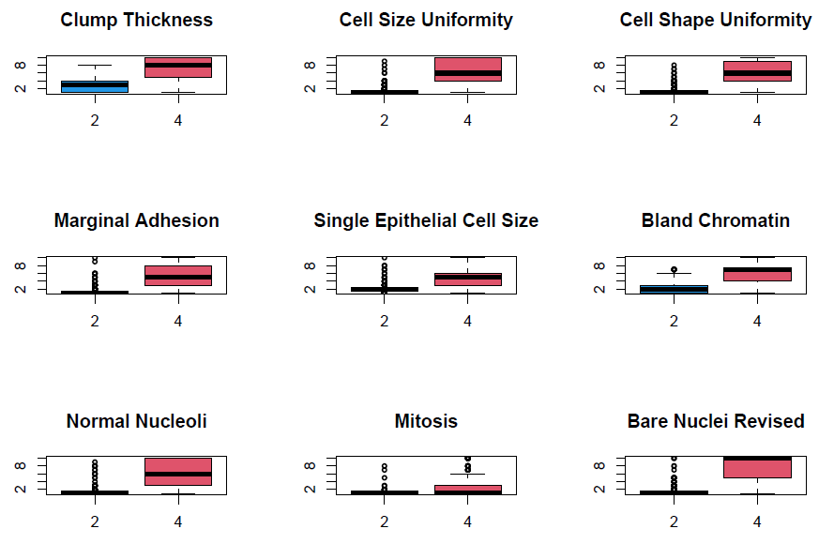

Figure 1: Boxplot of observed variables

The boxplots above in Figure 1 were depicted for each variable for both benign and malignant tumors. As domenstrated in the graph, the benign tumors have more outliers compared to malignant tumors. Moreover, the values of each variable for benign appear smaller than those of malignant masses.

The chi-square plots in Figure 2 were created to validate the assumption of normality. If the multivariate normality assumption is correct, the points should follow a straight line. It is true for the malignant class, but a curve is detected for the benign class which suggests a departure from normality. The two points that show the largest deviation from the linear trend are highlighted in red circles. But considering the sample sizes ($m=$ 458; $n=$ 251) are large enough, Hotelling’s $T^{2}$ test is still quite robust even if there are departures from normality and several outliers are observed.

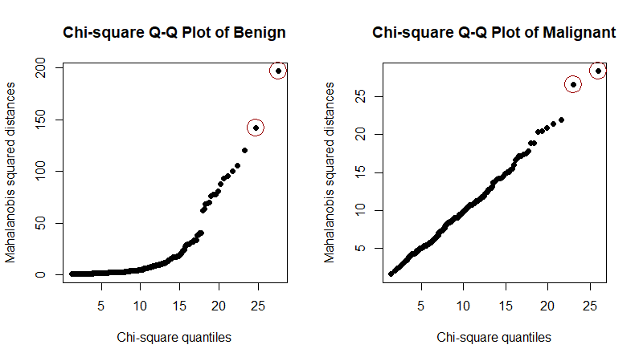

Figure 2: Chi-square plot for the benign and malignant tumors

The test statistic $T^{2}$ is 404.66 with 9 and 689 degrees of freedom. We reject the null hypothesis with a p-value of < $2.2e-16$ and conclude there are significant differences in the mean vectors of benign and malignant tumors.

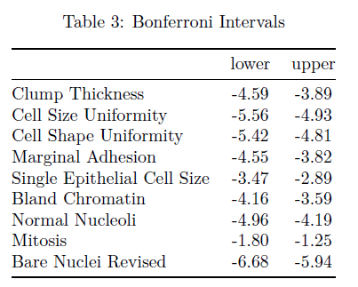

The 95% Bonferroni intervals for $μ_{1}-μ_{2}$ are displayed above in Table 3. Since the lower and upper bound of the intervals are negative for each variable and do not contain zero, it indicates that the values of each variable for benign tumors are significantly lower than those for malignant tumors.

***Principal Components Analysis (PCA) Results***

*Scientific Question #2: Can we use PCA to reduce the dimensionality of the data and to identify/summarize crucial variables?*

The results of the PCA importance of components are displayed below in Table 4. The output shows that 74% of the total variation in the training data can be explained by PC1 and PC2. We typically retain PCs that explain between 70% and 95% of the total variation [5].

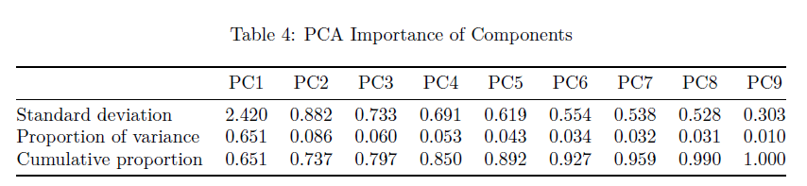

The scree plot depicted in Figure 3 below displays the amount of variance explained for each PC. The scree plot shows a bend at PC2 which indicates that we should retain at least PC1 and PC2. Based on the cumulative proportion of variance explained and inspection of the scree plot, we will retain PC1 and PC2 for further analysis.

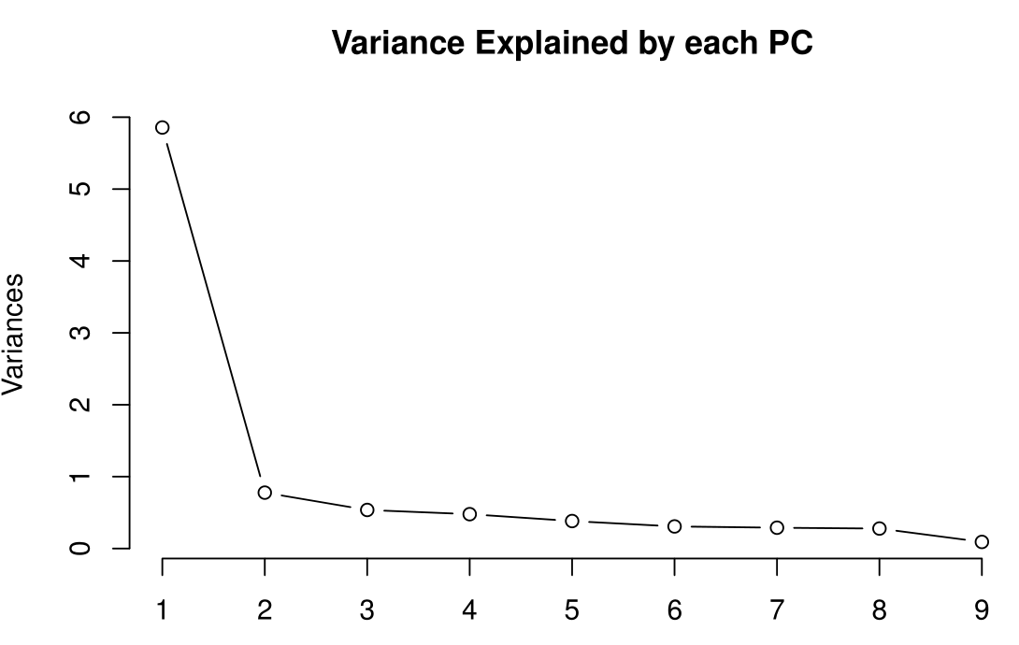

Figure 3: Scree Plot

The loadings of the first two PCs are shown below in Table 5.

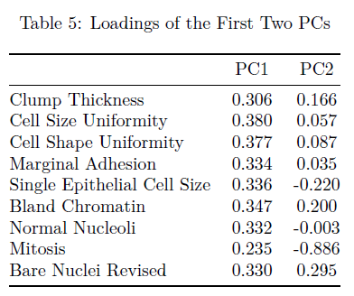

Hence the first PC can be constructed as follows: $Y_{1}{ = 0.306X}_{1}+ 0.380X_{2}+{0.377X}_{3}+0.334X_{4}+0.336X_{5}+0.347X_{6}+0.332X_{7}+0.235X_{8}+0.330X_{9 }$

We can interpret the first PC as a roughly equally weighted sum of the nine features.

Hence the second PC can be constructed as follows:

$Y_{2}{ = 0.166X}_{1}+0.057X_{2}+0.087X_{3}+0.035X_{4}-0.220X_{5}+0.200X_{6}-0.003X_{7}-0.886X_{8}+0.295X_{9 }$

We can interpret the second PC as a contrast between Mitosis and Single Epithelial Cell Size with Clump Thickness, Bland Chromatin, and Bare Nuclei Revised. The PC2 loadings for the other four features (Cell Size Uniformity, Cell Shape Uniformity, Marginal Adhesion, and Normal Nucleoli) are close to zero and are not important in PC2. Although several features are important for PC2, the second PC is strongly weighted by Mitosis.

$Y_{1}$ and $Y_{2}$ represent the PC scores which are computed by multiplying the standardized training dataset by their respective PC loadings. The PC scores are then used as the predictors in the classification models. Figure 4 displays a scatter plot of PC1 scores and PC2 scores colored by class (black represents benign and red represents malignant).

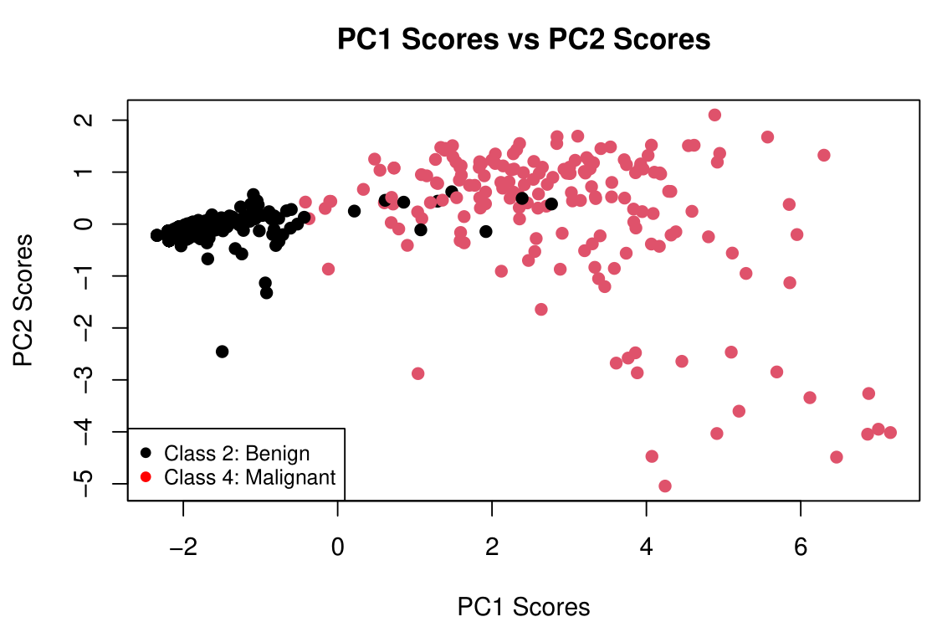

Figure 4: Scatter Plot

***Classification Results***

*Scientific Question #3: Which classification model yields the highest accuracy for predicting if a tumor is benign or malignant?*

To assess which classifier is best out of the ones specified in the methods section, we performed 5-fold cross validation and repeated the process 20 times for 100 total resamples for each of the models on the untransformed training data. We repeated this for the training data transformed by the first two principal components. We then looked at the distributions of the cross-validation accuracies and Cohen's $κ$ s.

As a benchmark for all the models, we calculated the no information rate in the training and testing data. This is the accuracy of predicting the most common class for all observations [6]. The model accuracy must have a higher accuracy than the no information rate to be useful. The no information rate in the training data is about 64.21% and is about 68.57% in the testing data.

In the 100 resamples, all of the models significantly outperformed the no information rate for the training data. The models trained on the data transformed by the first two principal components outperformed their counterparts trained on the raw training data, on average. From the models trained on the first two principal components scores of the training data, the KNN (*k* = 3), the Classification Tree (*cp* = 0.5), and the SVM (*C* = 1, *Sigma* = 4) had the best performances in accuracy and Cohen's $κ$. The KNN (*k* = 3) and Classification Tree (*cp* = 0.5) slightly outperformed the SVM and are simpler models, so we proceeded with those models for testing on the withheld testing data set. Table 9 and Table 10 in the appendix contain the numeric summaries depicted in the boxplots in Figure 5 below.

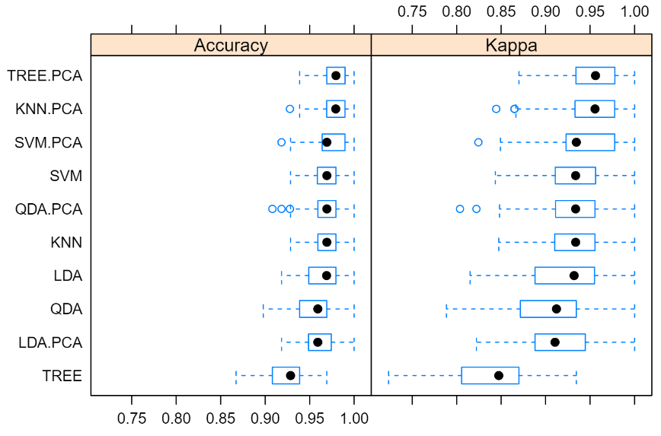

Figure 5: Box Plots of Resampling Accuracy and Cohen’s $κ$ 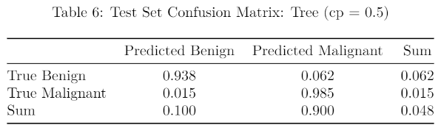

We transformed the withheld testing data set with a prcomp object fit to the training data to prevent data leakage. The KNN (*k* = 3) model and Classification Tree (*cp* = 0.5) have identical performances on the testing data, so only the confusion matrix for the Classification Tree is shown above. The confusion matrix for the KNN (*k* = 3) model can be found in the appendix in Table 7.

The Classification Tree (*cp* = 0.5) and KNN (*k* = 3) model trained on the first two principal components scores had a test set accuracy of 95.2%. Conversely, they have an apparent error rate of 4.8%. The sensitivity, or true positive rate, is 98.5% and the specificity, or true negative rate, is 93.8%. These models have a higher sensitivity than specificity; they are more likely to correctly classify a malignant mass than a benign one. These models are more prone to false positives than false negatives.

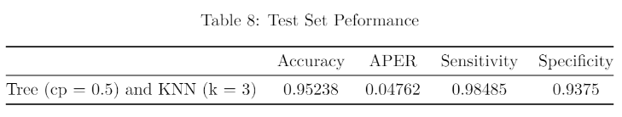

Both false positives and false negatives have very high costs when determining whether a breast mass is benign or malignant. A false positive, a benign mass classified as malignant, could result in an unnecessary treatment for cancer, which carries health and financial costs. A false negative, a malignant mass classified as benign, could delay a proper diagnosis and possibly result in death. The relative weights of these risks likely varies from individual to individual, but it is likely that most individuals would weight the risk of a false negative higher than a false positive.

**Conclusions**

We established that there are differences in the means of all variables between benign and malignant masses using Hotelling’s $T^{2}$ two-sample test. Next, we used PCA to find a 2-dimensional representation of the data that retained important information regarding these differences. Finally, we fit models to this 2-dimensional representation that successfully classified over 95% of out-of-sample observations. The models identified here may be useful to doctors. They cannot replace laboratory testing, but can provide doctors with a confident diagnosis pending laboratory test results.

**Appendix**

***Additional Tables and Figures***

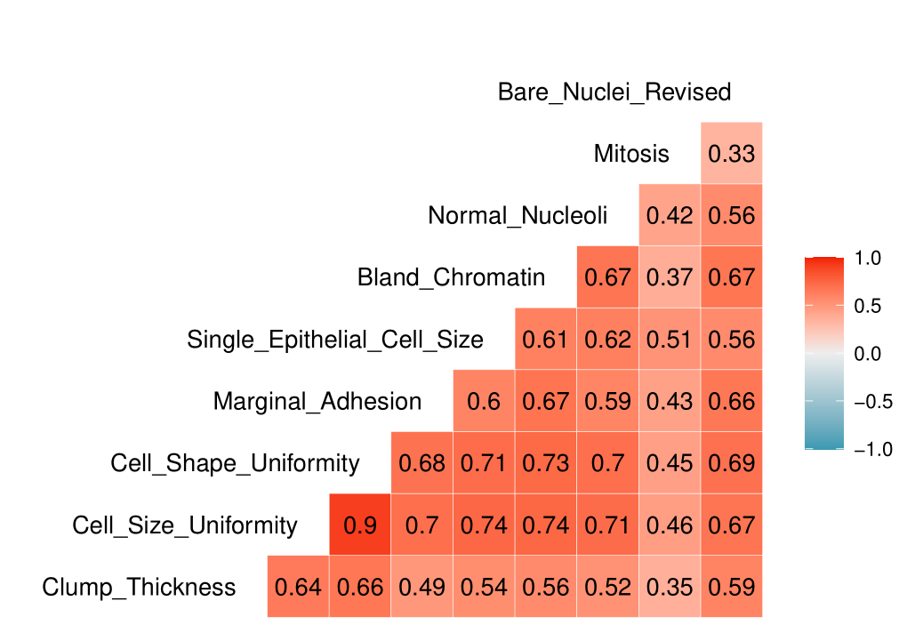

Figure 6: Correlation Plot

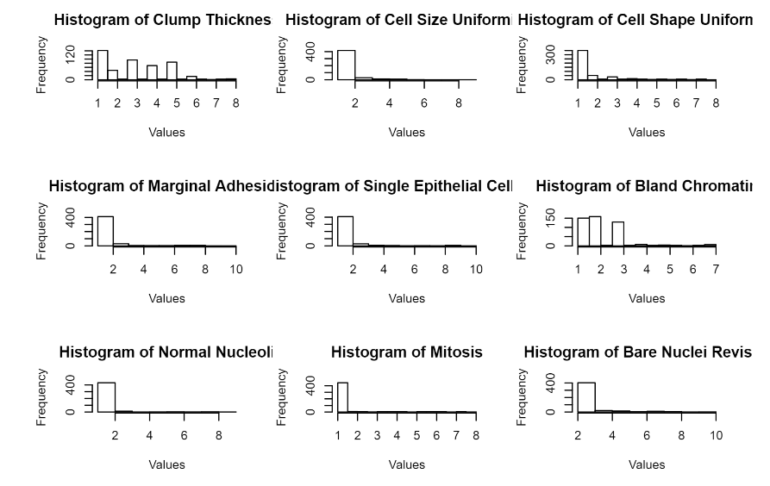

Figure 7: Histograms of Variables for Benign Masses

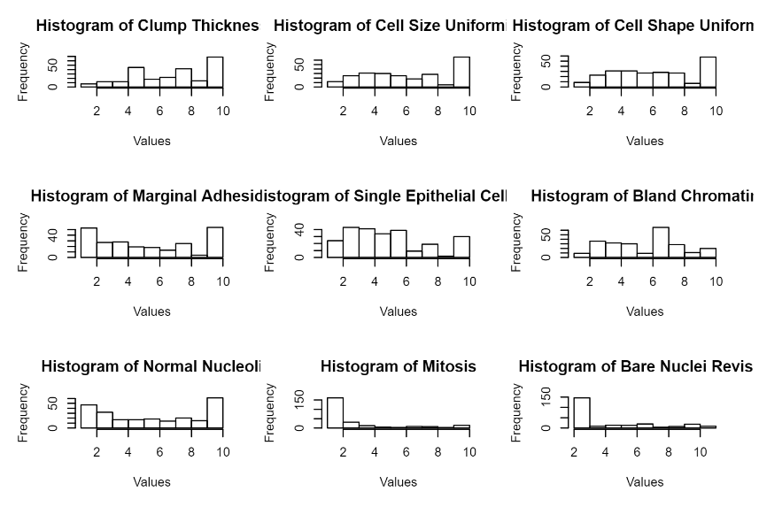

Figure 8: Histograms of Variables for Malignant Masses

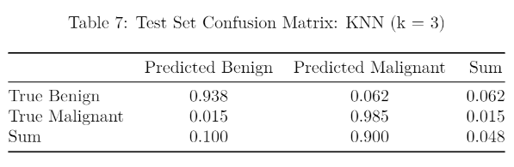

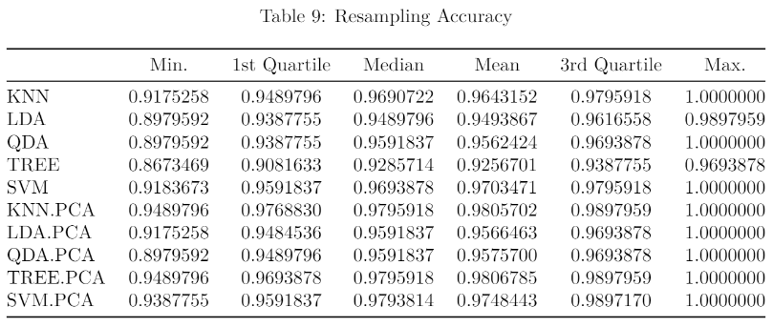

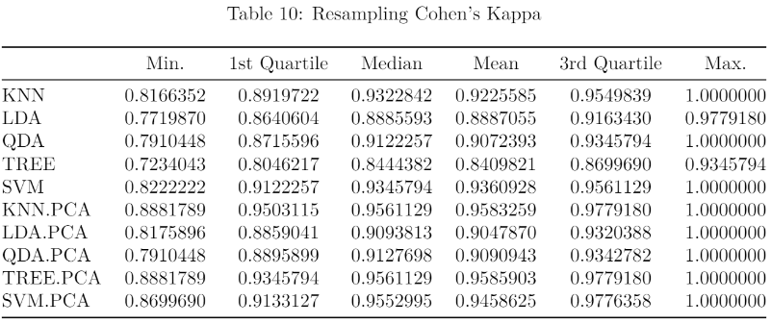

***R Code***

**## ----setup, include=FALSE------------------------------------------------------------------------------**

**knitr::opts_chunk$set(echo = TRUE)**

**## ------------------------------------------------------------------------------------------------------**

**suppressWarnings(library(tidyverse))**

**##### DATA CLEANING #####**

**# Read in data set.**

**# Read in the Breast Cancer data set.**

**#setwd("C:/Users/17739/Documents/GitHub/BreastCancerDetection/Breast Cancer Git Hub/")**

**bc.df <- read.table("Data/breast-cancer-wisconsin.data", sep=",")**

**# Add informative column names.**

**colnames(bc.df) = c("Id", "Clump Thickness", "Cell Size Uniformity",**

**"Cell Shape Uniformity", "Marginal Adhesion",**

**"Single Epithelial Cell Size", "Bare Nuclei",**

**"Bland Chromatin", "Normal Nucleoli", "Mitosis",**

**"Class")**

**# Calculate median Bare Nuclei by Class.**

**median.BareNuclei.2 <- bc.df %>%**

**group_by(Class) %>%**

**summarize(Median = median(as.numeric(`Bare Nuclei`),**

**na.rm=TRUE))%>%filter(Class == 2)**

**median.BareNuclei.4 <- bc.df %>%**

**group_by(Class) %>%**

**summarize(Median = median(as.numeric(`Bare Nuclei`),**

**na.rm=TRUE))%>%filter(Class == 4)**

**# Impute missing Bare Nuclei data with the median for each Class mean.**

**bc.df <- bc.df %>%**

**mutate(`Bare Nuclei Revised` = ifelse(`Bare Nuclei` == "?" & Class == 2,**

**round(median.BareNuclei.2$Median,2),**

**ifelse(`Bare Nuclei` == "?" & Class == 4,**

**round(median.BareNuclei.4$Median,2), `Bare Nuclei`)))**

**# Convert Bare Nuclei Revised data to the int data type.**

**bc.df$`Bare Nuclei Revised` <- as.integer(bc.df$`Bare Nuclei Revised`)**

**# Convert Class to a factor variable.**

**bc.df$Class = as.factor(bc.df$Class)**

**##### SUMMARY STATISTICS #####**

**bc.df.mean <- dplyr::select(bc.df, -c("Id","Bare Nuclei")) %>% group_by(Class) %>% summarise_all("mean")**

**#transpose from wide to long**

**bc.df.mean<-as.data.frame(t(dplyr::select(bc.df.mean,-"Class")))**

**colnames(bc.df.mean) <- c("Benign", "Malignant")**

**bc.df.sd <- dplyr::select(bc.df, -c("Id","Bare Nuclei")) %>% group_by(Class) %>% summarise_all("sd")**

**#transpose from wide to long**

**bc.df.sd<-as.data.frame(t(dplyr::select(bc.df.sd,-"Class")))**

**colnames(bc.df.sd) <- c("Benign", "Malignant")**

**##### DATA SPLITTING #####**

**# Set a random seed for reproducibility.**

**set.seed(17)**

**# Count the number of observations in the data set.**

**num.obs <- dim(bc.df)[1]**

**# Set the proportion of observations to be in the training data set.**

**prop.train <- 0.7**

**# Set the number of observations to be in the training data set.**

**num.train <- round(num.obs*prop.train)**

**# set the indicies of the dataset to be in the training data set.**

**train.indices <- sample(1:num.obs, num.train, replace=FALSE)**

**# Subset the data into training and testing data sets.**

**train.bc.df <- bc.df[train.indices,]**

**test.bc.df <- bc.df[-train.indices,]**

**# Save the vector of the indicies of the independent variable columns.**

**X_col_indicies <- c(2, 3, 4, 5, 6, 8, 9, 10, 12)**

**## ------------------------------------------------------------------------------------------------------**

**knitr::kable(bc.df.mean, align = "c",**

**caption = "Mean Summary Statistics", digits = 2)**

**## ------------------------------------------------------------------------------------------------------**

**knitr::kable(bc.df.sd, align = "c",**

**caption = "Standard Deviation Summary Statistics", digits = 3)**

**## ------------------------------------------------------------------------------------------------------**

**# pair plot**

**pairs(bc.df[,-c(1,7,11)],**

**col = c(4, 2)[as.numeric(bc.df$Class)], # Change color by group**

**pch = c(8, 1)[as.numeric(bc.df$Class)], # Change points by group**

**main = "Pair Plot of Benign and Malignant for All Variables", oma=c(2,2,2,16))**

**par(xpd = TRUE)**

**legend("bottomright", col=c(4, 2),pch = c(8, 1),**

**legend = c("Benign", "Malignant"))**

**## ------------------------------------------------------------------------------------------------------**

**# boxplot**

**par(mfrow=c(3,3))**

**for(col_index in X_col_indicies){**

**boxplot(bc.df[,col_index] ~ Class, data = bc.df, col=c(4,2),**

**xlab="", ylab = "", main=names(bc.df)[col_index])**

**}**

**## ------------------------------------------------------------------------------------------------------**

**suppressWarnings(library(ICSNP))**

**# Seperate the 2 classes into dataframes for mean vector comparison.**

**X = as.matrix(bc.df[bc.df$Class == "2", X_col_indicies]) # class 2**

**Y = as.matrix(bc.df[bc.df$Class == "4", X_col_indicies]) # class 4**

**#normality check**

**################## chisquare.plot ##############**

**chisquare.plot <- function(x, mark, title) {**

**# x = A nxp data matrix, mark: number of extreme points to mark,**

**# p = number of variables, n = sample size**

**p <- ncol(x)**

**n <- nrow(x)**

**# xbar and s**

**xbar <- colMeans(x)**

**s <- cov(x)**

**# Mahalanobis dist, sorted**

**x.cen <- scale(x, center = T, scale = F)**

**d2 <- diag(x.cen %*% solve(s) %*% t(x.cen))**

**sortd <- sort(d2)**

**# chi-sq quantiles**

**qchi <- qchisq((1:n - 0.5)/n, df = p)**

**# plot, mark points with heighest distance**

**plot(qchi, sortd, pch = 19, xlab = "Chi-square quantiles",**

**ylab = "Mahalanobis squared distances",**

**main = title)**

**points(qchi[(n - mark + 1):n], sortd[(n - mark + 1):n], cex = 3, col = "#990000")**

**}**

**###########################################**

**par(mfrow=c(1,2))**

**chisquare.plot(X,2, "Chi-square Q-Q Plot of Benign")**

**chisquare.plot(Y,2, "Chi-square Q-Q Plot of Malignant")**

**## Two-sample Hotelling's T2 test**

**HotellingsT2(X,Y)**

**## Bonferroni intervals**

**alpha = 0.05 # old significance level**

**p = 2 # number of intervals/variables**

**# mean vectors**

**xbar = colMeans(X)**

**ybar = colMeans(Y)**

**difference = xbar - ybar**

**# covariances of each group**

**S.x = cov(X)**

**S.y = cov(Y)**

**# bc.df statistics summary**

**stats = round(cbind(xbar, ybar, sqrt(diag(S.x)), sqrt(diag(S.y))),3)**

**colnames(stats) = c("Benign Mean", "Malignant Mean", "Benign Sd", "Malignant Sd")**

**stats**

**# sample sizes**

**m = nrow(X)**

**n = nrow(Y)**

**# pooled covariance matrix**

**S.pool = ((m-1)*S.x + (n-1)*S.y) / (m + n - 2)**

**# critical value**

**crit = qt(alpha/(2*p), df = m+n-2, lower.tail = F)**

**## ------------------------------------------------------------------------------------------------------**

**# Bonferroni intervals**

**half.width = crit*sqrt(diag(S.pool)*(1/m + 1/n))**

**lower = difference - half.width**

**upper = difference + half.width**

**int.bonf = round(cbind(lower, upper),3)**

**knitr::kable(int.bonf, align = "c", caption = "Bonferroni Intervals", digits = 2)**

**## ------------------------------------------------------------------------------------------------------**

**##### PCA (Principle Components Analysis #####**

**# Scientific Question 2**

**# Can we use PCA to reduce the dimensionality of the data and**

**# to identify/summarize crucial variables?**

**suppressWarnings(library(knitr))**

**suppressWarnings(library(GGally))**

**# Split the training and testing data sets into independent**

**# variables and dependent variables.**

**train.bc.df.class <- train.bc.df$Class**

**train.bc.df.X <- train.bc.df[, X_col_indicies]**

**test.bc.df.class <- test.bc.df$Class**

**test.bc.df.X <- test.bc.df[, X_col_indicies]**

**# Plot a correlation matrix.**

**ggcorr(train.bc.df.X, label=TRUE, label_size=3, label_round=2)**

**# Shows that Cell Shape Uniformity and Cell Size Uniformity are highly correlated (0.90).**

**cor(train.bc.df.X)**

**## ------------------------------------------------------------------------------------------------------**

**# Standardize the variables.**

**train.bc.df.X.std <- scale(train.bc.df.X, center=TRUE, scale=TRUE)**

**# Perform PCA.**

**data.pca <- prcomp(train.bc.df.X.std)**

**# Extract the importance of each component.**

**# standard deviation**

**st.dev <- data.pca$sdev**

**# variance**

**var <- st.dev^2**

**# total variance**

**TV <- sum(var)**

**#proportion of variance explained**

**prop <- var/TV**

**#cumulative proportion of variance explained**

**pve <- cumsum(var)/TV**

**#combine in a table**

**tab <- rbind(st.dev, prop, pve)**

**rownames(tab) <- c("Standard deviation", "Proportion of variance",**

**"Cumulative proportion")**

**colnames(tab) <- paste0("PC",1:9)**

**knitr::kable(tab, align = "c",**

**caption = "PCA Importance of Components", digits = 3)**

**## ------------------------------------------------------------------------------------------------------**

**# Make a Scree Plot to help determine how many PCs to retain.**

**screeplot(data.pca, type = "line", main = "Variance Explained by each PC")**

**## ------------------------------------------------------------------------------------------------------**

**# The elbow in the graph is at PC2.**

**# PC 1 and 2 explain 74% of the variability**

**# Display the loadings for PC1 and PC2 for review.**

**#round(data.pca$rotation[, 1:2], 3)**

**knitr::kable(data.pca$rotation[, 1:2], align = "c",**

**caption = "Loadings of the First Two PCs", digits = 3)**

**## ------------------------------------------------------------------------------------------------------**

**# PC1 is roughly equally weighted.**

**# PC2 is essentially the effect of Mitosis.**

**PC1 <- data.pca$rotation[, 1]**

**PC2 <- data.pca$rotation[, 2]**

**PC.scores.1 <- train.bc.df.X.std %*% PC1**

**PC.scores.2 <- train.bc.df.X.std %*% PC2**

**# Plot PC score 1 vs PC score 2 colored by class.**

**plot(PC.scores.1,PC.scores.2, pch=19, col=train.bc.df.class, main = "PC1 Scores vs PC2 Scores", xlab = "PC1 Scores", ylab = "PC2 Scores")**

**legend("bottomleft", legend=c("Class 2: Benign", "Class 4: Malignant"),**

**col=c("black", "red"), pch=19, cex=0.8)**

**## ------------------------------------------------------------------------------------------------------**

**# Create a dataframe only holding the X variables and the Class, starting with the X variables.**

**train.df = train.bc.df.X**

**test.df = test.bc.df.X**

**# Re-attach the Class to the independent variables of the training and testing dataframes.**

**train.df$Class <- train.bc.df.class**

**test.df$Class <- test.bc.df.class**

**# This is essential to get rpart to run on this data.**

**colnames(train.df) <- make.names(colnames(train.df))**

**colnames(test.df) <- make.names(colnames(train.df))**

**# Set the number of principal components to keep.**

**num.keep <- 2**

**# Re-fit prcomp() so it knows to center and scale input data.**

**pca.fit <- prcomp(train.bc.df.X, center=TRUE, scale=TRUE)**

**summary(pca.fit)**

**# Create a new dataframe to hold the prcomp() transformed training data.**

**train.pca <- as.data.frame(pca.fit$x[, 1:num.keep])**

**# Create a new dataframe to hold the prcomp() transformed testing data.**

**test.pca <- as.data.frame(predict(pca.fit, test.bc.df.X)[, 1:num.keep])**

**# Re-attach the Class to the PCA-trainsformed training and testing dataframes.**

**train.pca$Class <- train.bc.df.class**

**test.pca$Class <- test.bc.df.class**

**## ------------------------------------------------------------------------------------------------------**

**# Calculate the no information rates.**

**no.info.rate.train <- sum(train.pca$Class == 2) / length(train.pca$Class)**

**no.info.rate.test <- sum(test.pca$Class == 2) / length(test.pca$Class)**

**print(paste("No Information Rate (Training Set): ",**

**round(100*no.info.rate.train, 3), "%", sep=""))**

**print(paste("No Information Rate (Testing Set): ",**

**round(100*no.info.rate.test, 3), "%", sep=""))**

**## ------------------------------------------------------------------------------------------------------**

**suppressWarnings(library(caret))**

**suppressWarnings(library(kernlab))**

**# We will be using 5-fold cross-validation, repeating the process 20 times.**

**TrControl <- trainControl(method = "repeatedcv",**

**number = 5,**

**repeats = 20)**

**# Fit a KNN classifier by selecting the model with the best number of neighbors**

**# by performing 5-fold cross-validation tuning the k parameter using the odd numbers**

**# from 1 up to 9.**

**knn.model <- train(Class ~ ., data = train.df,**

**method = "knn",**

**trControl = TrControl,**

**tuneGrid = expand.grid(k = seq(1, 9, by=2)))**

**# Perform 5-fold cross-validation using a LDA classifier.**

**lda.model <- train(Class ~ ., data = , train.df,**

**method = "lda",**

**trControl = TrControl)**

**# Perform 5-fold cross-validation using a QDA classifier.**

**qda.model <- train(Class ~ ., data = , train.df,**

**method = "qda",**

**trControl = TrControl)**

**# Fit a tree classifier by selecting the model with the best complexity parameter (cp)**

**# by performing 5-fold cross-validation tuning the cp parameter using 0.001, 0.01,**

**# and 0.1**

**tree.model <- train(Class ~ ., data = train.df,**

**method = "rpart",**

**trControl = TrControl,**

**tuneGrid = expand.grid(cp = seq(0.05, 0.5, by=0.05)))**

**# Fit a SVM classifier with a radial kernel by selecting the model tuning the C and**

**# sigma parameters by performing 5-fold cross-validation tuning**

**# the C parameter from 0.25 to 4, doubling each time, and the sigma parameter from**

**# 0.125 to 8, doubling each time**

**svm.model <- train(Class ~ ., data = train.df,**

**method = "svmRadial",**

**trControl = TrControl,**

**tuneGrid = expand.grid(C = 2^c(-2:2),**

**sigma = 2^(-3:3)))**

**# Fit a KNN classifier by selecting the model with the best number of neighbors**

**# by performing 5-fold cross-validation tuning the k parameter using the odd numbers**

**# from 1 up to 9.**

**knn.model.pca <- train(Class ~ ., data = train.pca,**

**method = "knn",**

**trControl = TrControl,**

**tuneGrid = expand.grid(k = seq(1, 9, by=2)))**

**# Perform 5-fold cross-validation using a LDA classifier.**

**lda.model.pca <- train(Class ~ ., data = , train.pca,**

**method = "lda",**

**trControl = TrControl)**

**# Perform 5-fold cross-validation using a QDA classifier.**

**qda.model.pca <- train(Class ~ ., data = , train.pca,**

**method = "qda",**

**trControl = TrControl)**

**# Fit a tree classifier by selecting the model with the best complexity parameter (cp)**

**# by performing 5-fold cross-validation tuning the cp parameter using 0.001, 0.01,**

**# and 0.1**

**tree.model.pca <- train(Class ~ ., data = train.pca,**

**method = "rpart",**

**trControl = TrControl,**

**tuneGrid = expand.grid(cp = seq(0.05, 0.5, by=0.05)))**

**# Fit a SVM classifier with a radial kernel by selecting the model tuning the C and**

**# sigma parameters by performing 5-fold cross-validation tuning**

**# the C parameter from 0.25 to 4, doubling each time, and the sigma parameter from**

**# 0.125 to 8, doubling each time**

**svm.model.pca <- train(Class ~ ., data = train.pca,**

**method = "svmRadial",**

**trControl = TrControl,**

**tuneGrid = expand.grid(C = 2^c(-2:2),**

**sigma = 2^(-3:3)))**

**# Summarize the Accuracy and Cohen's Kappa for each model in the 5-fold CV.**

**resamp <- resamples(list(KNN = knn.model, LDA = lda.model, QDA = qda.model,**

**TREE = tree.model, SVM = svm.model,**

**KNN.PCA = knn.model.pca, LDA.PCA = lda.model.pca,**

**QDA.PCA = qda.model.pca, TREE.PCA = tree.model.pca,**

**SVM.PCA = svm.model.pca))**

**## ------------------------------------------------------------------------------------------------------**

**quart.1st <- function(x){**

**# This helper function finds the first quartile.**

**return(quantile(x, probs=0.25))**

**}**

**quart.3rd <- function(x){**

**# This helper function finds the third quartile.**

**return(quantile(x, probs=0.75))**

**}**

**resample.summary <- function(resample, ordered.model.names, accuracy=TRUE){**

**# This function takes in a resample object, a vector of the models tested**

**# in order, and a boolean for accuracy. If accuracy is true, it returns**

**# a dataframe summary of the resampling accuracy for each model. Else,**

**# it returns a dataframe summary of the resampling Cohen's kappa for**

**# each model.**

**if(accuracy == TRUE){**

**# Summarize the accuracies.**

**X = resample$values[,seq(2, dim(resample$values)[2], 2)]**

**}**

**else{**

**# Summarize the Cohen's Kappas.**

**X = resample$values[,seq(3, dim(resample$values)[2], 2)]**

**}**

**my.min <- apply(X,MARGIN=2, FUN=min)**

**my.1st <- apply(X, 2, quart.1st)**

**my.median <- apply(X, MARGIN=2, FUN=median)**

**my.mean <- apply(X, MARGIN=2, FUN=mean)**

**my.3rd <- apply(X, 2, quart.3rd)**

**my.max <- apply(X, MARGIN=2, FUN=max)**

**my.summary <- matrix(c(my.min,**

**my.1st,**

**my.median,**

**my.mean,**

**my.3rd,**

**my.max),**

**nrow=(dim(resample$values)[2]-1)/2)**

**my.summary <- as.data.frame(my.summary)**

**colnames(my.summary) <- c("Min.", "1st Quartile", "Median",**

**"Mean", "3rd Quartile", "Max.")**

**rownames(my.summary) <- ordered.model.names**

**return(my.summary)**

**}**

**## ------------------------------------------------------------------------------------------------------**

**# Get summaries of the resampling perfomances for the models trained on the raw**

**# data.**

**ordered.model.names <- c("KNN", "LDA", "QDA", "TREE", "SVM",**

**"KNN.PCA", "LDA.PCA", "QDA.PCA", "TREE.PCA", "SVM.PCA")**

**acc <- resample.summary(resamp, ordered.model.names, accuracy=TRUE)**

**kappa <- resample.summary(resamp, ordered.model.names, accuracy=FALSE)**

**## ------------------------------------------------------------------------------------------------------**

**# Make a boxplot of the model Accuracies and Cohen's Kappas.**

**bwplot(resamp)**

**## ------------------------------------------------------------------------------------------------------**

**suppressWarnings(library(klaR))**

**# Get the best hyperparameter for the tree model.**

**best.cp = tree.model.pca$bestTune$cp**

**# Get predictions for the test set from the tree model.**

**tree.preds <- predict(tree.model.pca, test.pca)**

**# Make a confusion matrix for the tree model.**

**tree.emat <- errormatrix(test.pca$Class, tree.preds,**

**relative = TRUE)**

**# Convert the confusion matrix for the tree model to a dataframe.**

**tree.emat <- as.data.frame(round(tree.emat, 3))**

**# Add informative row and column names.**

**colnames(tree.emat) <- c('Predicted Benign', "Predicted Malignant", "Sum")**

**rownames(tree.emat) <- c('True Benign', "True Malignant", "Sum")**

**## ------------------------------------------------------------------------------------------------------**

**# Get the best hyperparameter for the knn model.**

**best.k = knn.model.pca$bestTune$k**

**# Get predictions for the test set from the knn model.**

**knn.preds <- predict(knn.model.pca, test.pca)**

**# Make a confusion matrix for the knn model.**

**knn.emat <- errormatrix(test.pca$Class, knn.preds,**

**relative = TRUE)**

**# Convert the confusion matrix for the tree model to a dataframe.**

**knn.emat <- as.data.frame(round(knn.emat, 3))**

**# Add informative row and column names.**

**colnames(knn.emat) <- c('Predicted Benign', "Predicted Malignant", "Sum")**

**rownames(knn.emat) <- c('True Benign', "True Malignant", "Sum")**

**## ------------------------------------------------------------------------------------------------------**

**# Set the proportion of tree predictions equal to knn predictions.**

**proportion.equal <- sum(tree.preds == knn.preds) / length(tree.preds)**

**print(paste("Percent of Tree Model Predictions equal to K-NN Model Predictions: ",**

**round(100*proportion.equal, 5), "%", sep=""))**

**## ------------------------------------------------------------------------------------------------------**

**knitr::kable(tree.emat, align = "c",**

**caption = paste("Test Set Confusion Matrix: Tree (cp = ", best.cp, ")", sep=""))**

**knitr::kable(knn.emat, align = "c",**

**caption = paste("Test Set Confusion Matrix: KNN (k = ", best.k, ")", sep=""))**

**## ------------------------------------------------------------------------------------------------------**

**# Calculate the accuracy for the tree model.**

**tree.accuracy <- sum(tree.preds == test.pca$Class) / length(tree.preds)**

**# Calculate the APER for the tree model.**

**tree.aper <- sum(tree.preds != test.pca$Class) / length(tree.preds)**

**# Calculate the sensistivity for the tree model.**

**tree.true.pos <- test.pca[test.pca$Class == 4, "Class"]**

**tree.true.pos.preds <- tree.preds[test.pca$Class == 4]**

**tree.sensitivity <- sum(tree.true.pos == tree.true.pos.preds) / length(tree.true.pos)**

**# Calculate the specificity for the tree model.**

**tree.true.neg <- test.pca[test.pca$Class == 2, "Class"]**

**tree.true.neg.preds <- tree.preds[test.pca$Class == 2]**

**tree.specificity <- sum(tree.true.neg == tree.true.neg.preds) / length(tree.true.neg)**

**## ------------------------------------------------------------------------------------------------------**

**# Calculate the accuracy for the knn model.**

**knn.accuracy <- sum(knn.preds == test.pca$Class) / length(knn.preds)**

**# Calculate the APER for the knn model.**

**knn.aper <- sum(knn.preds != test.pca$Class) / length(knn.preds)**

**# Calculate the sensistivity for the knn model.**

**knn.true.pos <- test.pca[test.pca$Class == 4, "Class"]**

**knn.true.pos.preds <- knn.preds[test.pca$Class == 4]**

**knn.sensitivity <- sum(knn.true.pos == knn.true.pos.preds) / length(knn.true.pos)**

**# Calculate the specificity for the knn model.**

**knn.true.neg <- test.pca[test.pca$Class == 2, "Class"]**

**knn.true.neg.preds <- knn.preds[test.pca$Class == 2]**

**knn.specificity <- sum(knn.true.neg == knn.true.neg.preds) / length(knn.true.neg)**

**## ------------------------------------------------------------------------------------------------------**

**test.performance <- matrix(c(tree.accuracy, tree.aper, tree.sensitivity, tree.specificity),**

**nrow=1, byrow=TRUE)**

**rownames(test.performance) <- c(paste("Tree (cp = ", best.cp, ") and ", "KNN (k = ", best.k, ")", sep=""))**

**colnames(test.performance) <- c("Accuracy", "APER", "Sensitivity", "Specificity")**

**test.performance <- as.data.frame(test.performance)**

**knitr::kable(test.performance, align = "c",**

**caption = "Test Set Peformance", digits = 5)**

**## ------------------------------------------------------------------------------------------------------**

**knitr::kable(acc, align = "c",**

**caption = "Resampling Accuracy", digits = 7)**

**knitr::kable(kappa, align = "c",**

**caption = "Resampling Cohen's Kappa", digits = 7)**

**## ------------------------------------------------------------------------------------------------------**

**par(mfrow=c(3,3))**

**for(col_index in X_col_indicies){**

**hist(bc.df[,col_index],**

**main = paste("Histogram of", colnames(bc.df[col_index])),**

**xlab = "Values")**

**}**

**## ------------------------------------------------------------------------------------------------------**

**par(mfrow=c(3,3))**

**for(col_index in X_col_indicies){**

**hist(bc.df[bc.df$Class == 2,col_index],**

**main = paste("Histogram of", colnames(bc.df[col_index])),**

**xlab = "Values")**

**}**

**## ------------------------------------------------------------------------------------------------------**

**par(mfrow=c(3,3))**

**for(col_index in X_col_indicies){**

**hist(bc.df[bc.df$Class == 4,col_index],**

**main = paste("Histogram of", colnames(bc.df[col_index])),**

**xlab = "Values")**

**}**

**References**

[1] What Is Breast Cancer?: Breast Cancer Definition. (2019). Retrieved November 15, 2020, from https://www.cancer.org/cancer/breast-cancer/about/what-is-breast-cancer.html

[2] Somasundaram, G. D. (2011). Breast cancer prediction system using feature selection and data mining methods. International Journal of Advanced Research in Computer Science, 2(1)

[3] Dua, D. and Graff, C. (2019). UCI Machine Learning Repository [https://archive.ics.uci.edu/ml/datasets/breast+cancer+wisconsin+(original)]. Irvine, CA: University of California, School of Information and Computer Science.

[4] Maity, A. (2020). *Comparison of several mean vectors*. Personal Collection of Arnab Maity, NCSU Department of Statistics, Raleigh, NC.

[5] Maity, A. (2020). *Principal Components Analysis*. Personal Collection of Arnab Maity, NCSU Department of Statistics, Raleigh, NC.

[6] Maity, A. (2020). *Discriminant Analysis and Classification*. Personal Collection of Arnab Maity, NCSU Department of Statistics, Raleigh, NC.

[7] Alexandros Karatzoglou, Alex Smola, Kurt Hornik, Achim Zeileis (2004). kernlab - An S4 Package for Kernel Methods in R. Journal of Statistical Software 11(9), 1-20. http://www.jstatsoft.org/v11/i09/